**MGMT 323 Supply Chain Management Midterm Exam** 19th October 2022

**Question 1:** Describe and draw a supply chain for Imtiaz Super Market. Also discuss the supply chain operations for any vertically integrated product (Maximum 250 Words) **[10 Marks]**

# Question 2: The Green Giant store placed different offers for a pack of mixed vegetables. Given below is a table compiled to display historical observations (let “Y” be the number of packs sold and “X” be the price).

# Use the data shown in the table to determine regression equation, correlation coefficient and coefficient of determination.

# The supply chain manager has introduced a new upsized package of mixed vegetables with a selling price of $7 per pack. Predict the volume of units sold.

# [15 Marks]

# Y = 1454.604 – 277.628 x

# R = - 0.843

# R-Square = 0.711

|  |  |  |
| --- | --- | --- |
| **Observations** | **Price ($) (X)** | **Quantity Sold (Y)** |
| 1 | 2.70 | 760 |
| 2 | 3.50 | 510 |
| 3 | 2.0 | 980 |
| 4 | 4.20 | 250 |
| 5 | 3.10 | 320 |
| 6 | 4.05 | 480 |

# Question 3: The monthly demand for XYZ Auto Manufacturer is as follows,

|  |  |  |  |
| --- | --- | --- | --- |
| **Month** | **Demand (Units)** | **Month** | **Demand (Units)** |
| January | 100 | May | 105 |
| February | 80 | June | 110 |
| March | 110 | July | 125 |
| April | 115 | August | 120 |

* 1. Use the exponential smoothing method to forecast the number of units for February to September. The initial forecast for January was 105 units; **α** (alpha) = 0.2 **[05 Marks]**
  2. Calculate the absolute percentage error for each month from February through August and the MAD, MAPE and tracking signal of forecast error as of the end of August. **[10 Marks]**

***Formulae:***

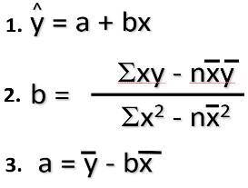

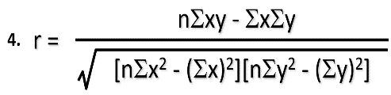

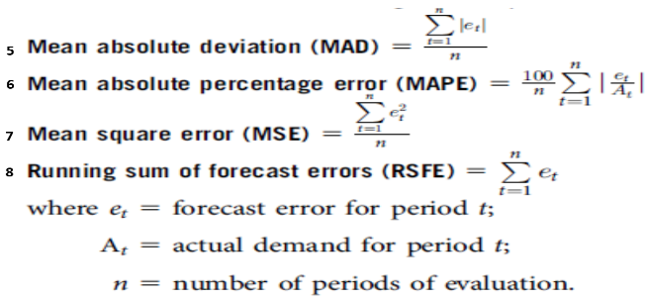

**5.** 𝐹𝑡+1 = 𝛼𝐴𝑡 + (1 − 𝛼)𝐹𝑡

**6.**Tracking Signal = MAPE / MAD

***End of Exam***

***Good Luck!!!***